
COMSATS UNIVERSITY ISLAMABAD,ATTOCK CAMPUS

COMPUTER SCIENCE DEPARTMENT
BSSE-3
PROJECT : UNILEVER

SUBMITTED TO:
DR HAMID MASOOD

SUBMITTED BY:
ZAINAB KHAN (FA22-BSE-032)
MEHMONA KANWAL(SP22-BSE-046)
DATE OF SUBMISSION:
15th oct,2023

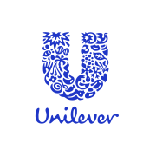
Contents
REPORT WRITING: 3
EXECUTIVE SUMMARY: 3
INTRODUCTION: 3
DISCRIPTION OF ORAGANIZATIONAL STRUCTURE: 4
STRUCTURE ANALYSIS 5
DECENTRALIZATION: 5
SWOT AND PEST ANYLYSIS 6
DEPARMENTALIZATION: 7
REPORTING RELATION: 8
DATA COLLECTION: 8
Digital Services: 8
Unilever Retail: 8
COMMUNICATION CHANNELS 9
DECISION MAKING PROCESS 9
CORPORATE SOCIAL RESPONSIBILITIES: 9
HIERARCHY: 10
Conclusion: 11
RECOMMENDATIONS: 11

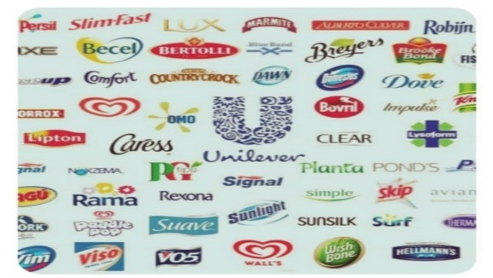

REPORT WRITING:

EXECUTIVE SUMMARY:
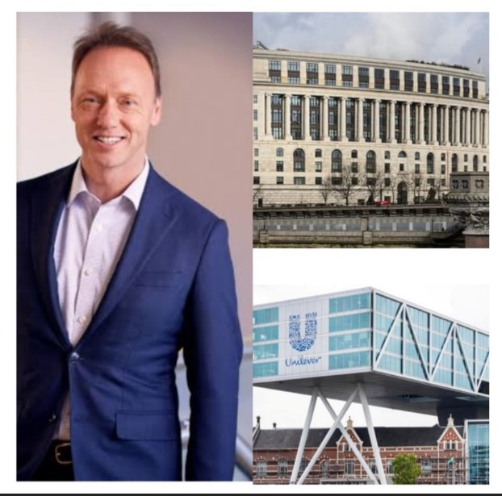
Unilever, which is a British multinational corporation ,it was established on 2ndSeptember,1929.it serving over 190 countries in the world, offering vast range of products used in everyday life.it own’s over 400 brands and expended itself by making strategic acquisitions gradually. The company have strong profit margins by effectively managing cost and optimizing income sources. The company is highlighted because its product portfolio and the commitment to corporate responsibilities.

INTRODUCTION:
The company is mainly headquartered in London UK. The CEO is Hien Schumacher. Unilever is also headquartered in Netherlands. The origin of the Unilever traced back by the merger of two separate companies Margarine Unie and Lever Brothers. The Margarine Unie Duch Margarine producers and Lever Brothers British soap maker. The company mainly operates in the Consumers Goods Industry Unilever provide extensive quantity of products as food products, cleaning agents, home care ,pharmaceuticals and skin care products. Unilever top brands are Dove, Sun Silk , Hellmann’s, Lux, Knorr and more. In the year,1930 Unilever purchased the United Africa Company established with a merger of Africa And Eastern Trade Corporation . Unilever completed innumerable corporate take overs in few years. Under the directions of Paul Polman the company shifted to Health And Beauty brands progressively.
In the early years , the company embarked on a journey to expand globally. The company had faced many challenges while entering world market . During the World War II the company was not able to reinvest in Nazi-occupation Europe , so it purchase some brands like TJ Lipton and Pepsodent in UK and US. Over the years the company made significant acquisitions with the famous brands Brooke Bond, Calvin Klein , Pond’s Creams , CheseBrough-Ponds and Elida Gibbs. In the late 20th century, the Unilever American business face a decline and company Adopted “hands off” policy for their management, at the same time the company thrived in other areas , particularly in ice cream. Unilever established a presence in Ghana through the merger of UAC Ghana limited .
In the 21st century the company made a strategic decisions of selling Dalda brand in Asian countries partnering with Rainforest alliance for sustainable tea sources the company also acquired personal care brand Sara Lee Corporation. In 2018 Unilever sold its margarine and spread divisions later it was renamed as Upfield. in the year 2019, the company contribute over €100m through donations of soap, hand sanitizer, bleach and food to help handling the situation during covid-19 pandemic.
In 2021, the company established a stand -alone beauty business called Elida Beauty ,by owning brands like Q-tips, Tony &Guys, lever 2000 and few more. The company also faced controversy due to its connection to Israel. Moreover, the company was agreed to sold 70 percent of its Tea business to Ekaterra division in 2021 aiming to invest in CVC Capital Partners.

DISCRIPTION OF ORAGANIZATIONAL STRUCTURE:
Unilever’s organizational structure is divided in to four main categories, as follows:
- Product based Departmentalization.
- Corporate executive team.
- Geographical divisions.
- Functional Structure.

Product based departmentalization:
In the year 2001 the company splits into two divisions the one for foods and the other one for home care and personal care. However , the company have three more divisions beauty and wellbeing , nutrition and ice cream .The company used this approach to allocate specific resources to each department easily and work efficiently. Moreover, this allows Unilever gain customer focus and innovating different products of high quality.

Corporate executive team:
Executive team is responsible for setting goals and directions for the company by ensuring alignment with company’s long-term objectives. The team is also playing important role in taking major decisions and changing the working strategy of the company globally. Moreover, the team also have responsibility of monitoring the performance of the different departments and overall progress of the company.
Geographical divisions:
Unilever also adopt a geographical structures in few regions, like Asia, North America and Europe. Each region have its own management. The company took this step to gain competitive advantages, as the company is operating in an industry with huge competition. As the company is operating in many countries and regions, so the geographical divisions also help in global coordination. This sort of division help company in local market understanding and adopting strategies to meet the customer expectations regarding different products in each region.
Functional Structure:
In the various divisions in different regions the Unilever is managing the functional departments, as HR, Supply Chain and finance management . These are the major functions transit the product departmentalization and geographical divisions , providing sport to the organization as a whole .
STRUCTURE ANALYSIS:
The Unilever is currently a decentralized company , the company is having dual- headed structure with two parent companies Unilever N.V and Unilever PLC. The company designed this structure because it allows Unilever to work in both countries at the same time the UK and Netherland. The decentralized structure strengthen after cold war, but from 2005 to 2009 the company was having centralized structure, due to globalization and increased competition Unilever constantly shifted between centralized and decentralized organizational structure to optimize the operations and availing new market opportunities . The decentralized structure involves various business units around the World.

DECENTRALIZATION:
The key futures of the company decentralized structure are as follows:
FOCUS ON LOCAL BRANDS :The company focus on marketing the brands in different regions according to their cultures , which could be more responsive to local customer needs.
BUSINESS UNITS: The company operates numerous business units each of them is responsible for specific products of different categories with respect to geographical regions.
REGIONAL OPERATIONS: The company have regional offices in different parts of the world to manage all operations of the branches in those regions. Moreover, these offices have flexibility to adapt policies according to customer’s needs and expectations.
LOCAL LEADERSHIP: the branches in different regions have their own local leadership teams, this allow them to understand local market culture in a better way and change working strategies simultaneously according to the local demands.

SWOT AND PEST ANYLYSIS
SWOT ANALYSIS: The swot analysis provide the clear picture of the strength , weaknesses , opportunities and threats.
Strengths:
- Unilever adapted a worldwide brand acquisition strategy.
- The company have efficient operational structure.
- Market research and innovations helps in efficient product development.
WEAKNESSES:
- Well organized patent is lacking.
- Unilever neglect non-core brands.
- Varying nature of products.
- Dependent on retailers.
OPERTUNITIES:
- Providing job opportunities in various regions
- Availability of products according to customer needs and expectations.
- Brand equity exist.
THREATS:
- An intense competition in the industry.
- In case of economic fluctuation in any region the purchasing power of customer may cause negative impact on company’s profit margins.
PEST ANALYSIS: it allows to determine political , economic , social and technological factors ,may have impact on company.
Political factors: The political condition of the VARIOUS countries IS stable in which Unilever is operating . Also the government relations should be good with the government of different countries.
Economic factors: the rate of inflation in most of the countries is stable and price policy of the company is fixed in various regions
Social factors: Unilever is focused on well-being of the people by providing them friendly products.
Technological factors: Unilever is using number of emerging technologies like cloud computing, AI technologies, block chain and IoT.

DEPARMENTALIZATION:
- BRANDS AND PRODUCT CATEGORIES: The company consists of various department based on brands and products each department have different work plan and marketing strategies according to their respective regions and local demands.
- MARKETING: the company has a marketing department responsible for creating and implementing marketing plans and policies for the brands. This includes advertising and market research to understand consumer demands
- FINANCE: The Unilever finance department handles all financial aspects of the company, including budgeting, and allocating resources to each branch in different regions.
- SUPPLY CHAIN: the department is responsible for the movement of goods from production process to distribution. It manage procurement and make sure that products reach consumers.
- RESEARCH & DEVELOPMENT :The company make a heavy investment in R&D to develop new products and enhance existing products. The department plays a vital in innovation and help company to compete with others.
- HUMAN RESOURCES : The HR department focuses on employee development, and develop a best work environment for Unilever's global workforce. This department plays a vital role in sustaining the efficiency of the company as a whole.

REPORTING RELATION:
The man management committee involves the Chief Executive Officer of the Unilever .The company is further operational in three main regions, the America ,Asia / Africa and Western Europe .Further divisions in each region and countries are self sufficient with dedicated resources and assets in sales and marketing. As 138,000 people around the world are working with Unilever all are accountable to their executive team leaders , the team leaders are then answerable to respective vice chairmen , the vice chairmen are responsible to answer regional directors and regional directors are responsible to satisfy the chief executive officer. All the branches of Unilever follow the same organizational structure briefly shown in the hierarchy.

DATA COLLECTION:

Digital Services:
Corporate websites: this is mainly the portal for stake holders to access the information about the company sustainability efforts and its overall performance.
Brand websites: various brands of Unilever have their own dedicated sites providing different information about the specific products.
E-commers platforms: the company is successfully executing a category- driven e-commerce strategy. Unilever’s online selling is up to 42 percent.

Unilever Retail:
Super market and grocery stores: food products of the company are easily available in any regular grocery store. Essential everyday items are accessible to everybody.
Pharmacies: medicated skin care products like soaps, shampoos are sold in pharmacies.
Whole sale and bulk retailer: the company also distribute products in a bulk to retailers to assure availability of products in local markets.
COMMUNICATION CHANNELS:
Product labels: all the brands working with the Unilever provide product labels by displaying all the details that customer need to know to influence their buying decisions .
Consumer leaflets: Unilever produce brochures and consumer leaflets for promoting different products of various brands to make the people aware about the advantages to use the specific products.
Emails: the different e-mail addresses of Unilever for different regions are available on website customers can interact easily from anywhere.
Advertising and marketing: Bill Boards and media links are used by the company for advertisement of different brands and products. However, the Brand portfolio diversification and Data -driven marketing are the top marketing strategies of the Unilever.
Letters and press releases: The Unilever circulate the financial reports and do press releases to inform about the economic stability of the company to the investors. In this way the company open up the financial statements highlighting revenues and profit loss ratio of the company.
DECISION MAKING PROCESS:
A STRUCTURE APPROACH: The company develop a unique approach “Decision Making Under Uncertainty”. This is the methodical way of making decision that places anticipation and analysis at the core of their reasons for it.
DECISIONS AND INNOVATIONS: Decision tools Suite software supports the companies DMUU process. This software allows the company to create data- driven business cases for biggest innovations along with strategic decisions.
PALISADE’S SOFTWARE: This is the software used by the Unilever to support other business areas including safety , regulatory , supply chain etc. in every branch in different regions

CORPORATE SOCIAL RESPONSIBILITIES:
The company undertake its social responsibilities by focusing on the areas like:
Promoting health and hygiene: Unilever is promoting health and hygienic habits, by focusing on nutrition and waste management by providing necessary medical support through Telemedicine centers and health camps etc.
Environment sustainability and water conservation: The company is emphasizing on ecological balance by running campaigns for the protection of Flora and Funa, also making people aware about the importance of conservation of natural resources, especially water by active participation in government programs like National Rural Employment Guarantee scheme (MGNREGS)
RURAL EDUCATION AND ENTREPRENEURSHIP DEVELOPMENT: The company is playing vital role in strengthening rural areas by promoting alternative livelihoods , empowering women and promoting education through developing infrastructure of Anganwadi and primary schools etc. in rural areas.

HIERARCHY:

HR
FINANACE
PRESEDENT

STAFF

OPERATOR

TREASURY
ACCOUNTS

MARKETING
MANUFACTURING
PROCUREMENT
ENGINEERING
System Engineering

Customer Services
se
Purchasing
Fabrication
Electronics Engineering

Assembly
Receiving Inspection

Domestic Sale

Software Engineering

Testing
International Sales

Mechanical
Engineering
Production Engineering

Technical
Engineering

Conclusion:
In a nutshell, this report has outlined a thorough view of Unilever by shedding on the organizational structure and its influence on company’s operations worldwide.
The introduction emphasize the significance of the company as a fast-moving corporation in the consumer goods industry. In the very short tenure the company bought many brands which are popular across the world. This help the company to gain customer focus and success in local as well as global market place.
The organizational structures provide the detail view of the strategies which the company adopt step by step to build an exceptional reputation globally. All these plans help company to become a reliable consumer goods company and fulfilling the expectations of its customers. Also, the proper organizational structure has provided a secure foundation for effective risk management and coordination across different regions.
In light of these findings, incorporating innovations and stability with in a company framework Unilever has establish itself as a benchmark of excellence in global market place. Moreover, Unilever serves as a standard examples for many multinational companies.

RECOMMENDATIONS:
Three major weakness of Unilever are imitable nature of products, limited business diversification and dependencies on retailers. The recommendations are as follows:
PRODUCT INNOVATION: The company needs to continuously invest in product innovation to make the products more adaptable by customers .this could involve reformulation the existing products to meet the evolving health and sustainability trends
CEASE ACQUISITIONS: The Unilever needs to cease acquisitions and partnerships in the sectors with sluggish growth, this help the company to sustain the healthy profit relations. The Unilever should stop continuous expanding the business in the countries with unstable economic conditions.
DIRECT TO CUNSUMER: Unilever needs to invest in direct-to-consumer channels and establish direct relations with consumers to reduce dependency on retailers and provide value consumer data.

